**NPS – C Group Report (Milestones)**

Semester 1, 2023

Group members:

* Deeksha
* Divya
* Miku
* Swen

Milestones completed and included:

* MS 1 –––– p. 01
* MS 2 –––– p. 04

**Milestone 1:**

**1. Which real world problem have you chosen to work on? Why is it an important problem?**

We believe that there is currently a problem with coin laundries since most washing machines and driers are old and lacking IoT technology, thus there is no way of checking the machines’ status without physically being there. This is an important problem in poor, high crime rate areas around world as there is no technology to monitor laundry theft. Additionally, if we can fix this problem, it can also contribute towards a more efficient coin laundry system which can make the user’s lives better and also the business more profitable.

**2. What will your app do and how will it help solve or mitigate the problem?**

The simplest solution to this problem is to replace the washing machines with ones that have IoT capabilities. However, due to budget constraints faced by coin laundry businesses, we believe that finding a simpler, more cost-effective solution will be beneficial. Thus, we decided to tackle this problem by installing sound recognition devices in laundry rooms and keep track of the sound that the washing machines make when they start/finish and also check for human sounds to see if someone might start using the washing machine. These sound devices will be microphones that will connect to a main server which will wirelessly send the information to the users’ apps. This will allow users to know when the washing machines are free and when their laundry is finished from anywhere. It will also alert users if their machine has been paused or has stopped before completing the wash cycle.

**3. What is the central algorithm or class of algorithms that will enable this app to work?**

Audio fingerprinting algorithm, searching & sorting algorithm, and matching and verification algorithm

**What would the algorithm need to do (you can illustrate this with a flow chart) in your app?**

>Generate a unique fingerprint (which is a compact representation of key features in the audio) for a short snippet of audio from the washing machines (such as the starting music, doors getting slammed, etc.).

> Then, the algorithm automatically submits an audio snippet for recognition, which the app searches its database of precomputed fingerprints from a library of sounds to find matching fingerprints.

> Once potential matches are found, the app uses a matching and verification algorithm to confirm the sound’s authenticity and update the status of the machine.

**What resources (i.e. textbooks, authoritative web pages/blogs, YouTube videos, etc) have you found explaining the algorithm that you will use?**

>Wang, A. (2003, October). An industrial strength audio search algorithm. In Ismir (Vol. 2003, pp. 7-13). (<https://www.ee.columbia.edu/~dpwe/papers/Wang03-shazam.pdf>)

>Jovanovic, J. (2018). How does Shazam work? Music Recognition Algorithms, Fingerprinting, and Processing. (<https://www.toptal.com/algorithms/shazam-it-music-processing-fingerprinting-and-recognition>)

><https://github.com/toonketels/Notes/blob/master/how-shazam-works.md>

**What are the prerequisites to understand these resources and how easily do you think you will be able to understand them? (e.g. does it require coding ability, some type of math, etc)**

>We need some understanding of the fingerprinting algorithm and how sound is turned into hashes and bits.

>Regarding the searching & sorting algorithm, we have learned it in class so it will be easier.

>Verification algorithm also should be easier as it is only used to verify whether the sound is really correct or not (and the level of “correctness” of the output)

4. **Under what circumstances do you expect users to use your app? (e.g. will they use it in the**

**office as part of their job, part of their leisure time, will they use it on the move, etc)**

>They will use it when they are doing (coin) laundry but cannot wait in the laundromat since they don’t have time

**What is (are) the target demographic(s) for your app? (eg. students, working professionals, young, elderly, etc)**

>Students and other people who uses the coin laundry regularly.

**What issues, if any, might your users run into while using your app and which you have to keep in mind?**

>May pickup sounds that are not related to any of the washing machines and mistakenly recognize it as a sound from a washing machine.

**Milestone 2:**

**Data Flow Diagram**:

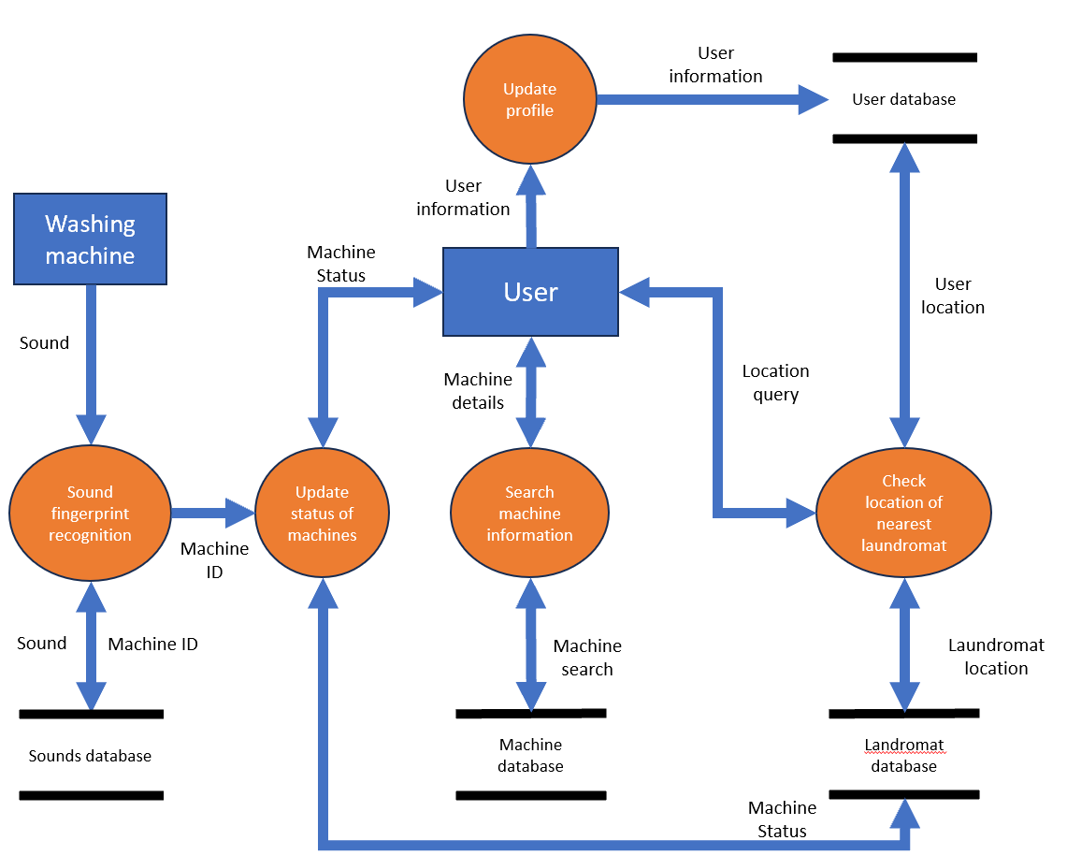

Question 1:

➢ **Sounds database**: A database storing the sounds of machines (starting and ending sounds/tones) as their fingerprint. Sounds picked up by the microphone are compared to sounds stored in this database to determine the status of the machine. The status is updated by the app and the user is alerted when the status of their washing machine changes.

➢ **Machine database**: A database to store information of all the machines at the laundromat. This database stores machine specific information such as machine model, serial number and maximum capacity of the machines. With this information, users can select their preferred machine by finding its capabilities on the app.

➢ **Laundromat database**: This database stores information about the laundromats at different locations that are using the app service. It stores the locations of the laundromats, their capacity, the number of free machines as well as information on the general trend of the time of the day when the laundromat is busy. Customers of the app can use this information to plan ahead when they can visit the laundromat.

➢ **User database**: Stores user account information, and provides the user an ID, so that a machine in use can be tagged to a particular user. This way, the app has information on which machines are free and which ones are not. The app stores personal particulars of a user such as their location and contact details. The users’ location information can be used to find the nearest laundromat.

Question 2:

**How the app will collect data**:

➔ The app will collect user information by asking the users to create an account within the app and enter their personal details such as their address and contact details.

➔ Audio information will be collected from the washing machines at the laundromat. This audio may pick up voices of users nearby which may include sensitive data.

➔ The app may record the location of user when they visit a laundromat. This information is stored at the laundromat database.

**Risk assessment**:

|  |  |  |  |  |
| --- | --- | --- | --- | --- |
| L  I  K  E  L  I  H  O  O  D | IMPACT | | | |
|  | Mild | Moderate | Severe |
| Unlikely | **Low** | **Low** | **Moderate** |
| Likely | **Low** | **Moderate** | **High** |
| Near certain | **Moderate** | **High** | **High** |

|  |  |  |  |
| --- | --- | --- | --- |
| Personal Information of Users is Stolen / Hacked | | | |
| Threat Event | Likelihood | Impact | Risk Level |
| 1. Loss of Confidentiality | UNLIKELY | SEVERE | MODERATE |
| 1. Loss of Integrity | UNLIKELY | MODERATE | LOW |
| 1. Loss of Availability | UNLIKELY | MODERATE | LOW |
| Overall Risk | | | MODERATE |

|  |  |  |  |
| --- | --- | --- | --- |
| Audio recording of users is leaked | | | |
| Threat Event | Likelihood | Impact | Risk Level |
| 1. Loss of Confidentiality | LIKELY | SEVERE | HIGH |
| 1. Loss of Integrity | UNLIKELY | MODERATE | MODERATE |
| 1. Loss of Availability | UNLIKELY | MODERATE | LOW |
| Overall Risk | | | HIGH |

|  |  |  |  |
| --- | --- | --- | --- |
| Laundromat database is Hacked and information, such as users’ locations, is leaked | | | |
| Threat Event | Likelihood | Impact | Risk Level |
| 1. Loss of Confidentiality | LIKELY | SEVERE | HIGH |
| 1. Loss of Integrity | LIKELY | MODERATE | MODERATE |
| 1. Loss of Availability | LIKELY | MODERATE | MODERATE |
| Overall Risk | | | HIGH |

**How to mitigate the risks**:

➢ Since a user's personal information, such as their location and contact information is collected, there is a need to safeguard this information from malicious attacks. Personal particulars can be transferred by using E2EE to protect from Man-in-the-middle attacks.

➢ Password protection / biometric authentication may be deployed during login to prevent hackers from remotely accessing users’ accounts’. Additionally, the password feature will include a 1-minute pause after 3 failed attempts and every subsequent attempt to prevent brute-force attacks.

➢ Audio recorded at the laundromat may include the voice of users present at the laundromat at the time of the recording. To ensure that users’ voices are not recorded, filters can be used to filter out voices. To prevent any theft of recorded audio, it must be ensured that the recorded audio is only stored for a short duration – to process only real-time information. Additionally, the central processor/computer at the laundromat will be password protected to prevent any attacks.

➢ All information stored at the databases must be encrypted to prevent data theft and data tampering.

**Link to Database Spreadsheet** (also uploaded to GitHub): [https://docs.google.com/spreadsheets/d/1od4B5BkRUa1PHsg0rrSf8elSqWeRompGXr24IAh_RNA/edit?usp= sharing](https://docs.google.com/spreadsheets/d/1od4B5BkRUa1PHsg0rrSf8elSqWeRompGXr24IAh_RNA/edit?usp=sharing)